For this written assignment, answer the following questions showing all of your work.

1. Find the domain of the function using interval notation.

[ f(x)= \frac{ \sqrt{x-6} }{ \sqrt{x-4} ](https://my.uopeople.edu/filter/tex/displaytex.php?texexp=%20f(x)=%20\frac%7b%20\sqrt%7bx-6%7d%20%7d%7b%20\sqrt%7bx-4%7d%20)

Ans x greater tha or equal to 6

2. Sketch a graph of a piecewise function. Write the domain in interval notation.

[Suggestion: for example, go to [www.desmos.com/calculator](http://www.desmos.com/calculator) and write

[ y=x^2 ](https://my.uopeople.edu/filter/tex/displaytex.php?texexp=%20y=x%5e2%20) for {-1 \leq x \leq 1}

And niche wale graph ka red part answer ha

y = 3x - 2 {1 \leq x \leq 3}

Then choose your own functions and have fun.]

Is graph ka blue answer ha

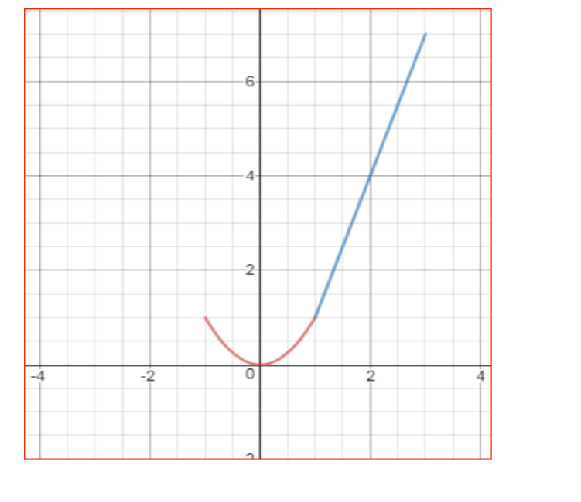

3.

The cost in dollars of making x items is given by the function *C*(x) = 10x + 500.

a. The fixed cost is determined when zero items are produced. Find the fixed cost for this item. 500

b. What is the cost of making 25 items? 750

c. Suppose the maximum cost allowed is $1500. What are the domain and range of the cost function, *C*(x)? 100